Ron Testing bugs

Hi Stew,
OK. It working but a couple of issues, these relate to remote mode.
1) Very little power output even with the Mic slider set to 100. The slider does work and it does adjust output power but I'm getting maybe 20W at most. I see in the SDRcore-trans log, that mic gain is being set to 100 so that is working correctly. Appears there is something wrong in the Remote Digital.
Fixed, QRP and AMP Cal was over written.

2). The Phone and Digital buttons should not be set or unset when in Remote Digital. The Phones and Digital buttons are still being overloaded with Remote configurations. When in remote mode and in the Remote window, clicking on Phone or Digital, the Phones and Digital buttons should not be accessed or changed. Again, when in Remote mode, pressing the Phones or Digital buttons should not change the Phones or Digital radial buttons in the Remote Digital Windows. The Phones and Digital buttons for controlling the audio paths that are local to the transceiver, only. Keep all three buttons as separate and independent functions.
A) Pressing Phones -> activates phones audio local to the transceiver (the other two buttons become inactive (but not disabled).
B) Pressing Digital - > activates digital audio local to the transceiver (the other two buttons become inactive (but not disabled).
C) Pressing Remote -> Brings up the Remote audio window (the other two buttons become inactive (but not disabled).
D) Then, Pressing Phone or Digital -> Deletes (or hides) the Remote audio window.
3) Question: Should the Proficio/Geminus button be active when the firmware reports a Proficio MKII PTT?
73,
Ron / W4MMP

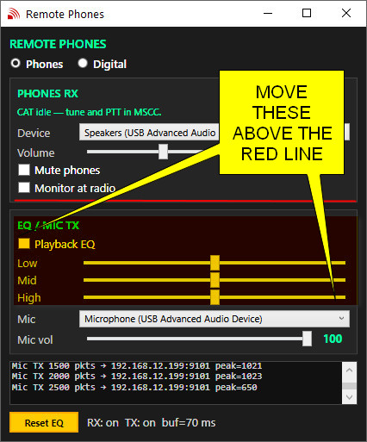
4). Just aesthetics :

Hi Stew,
5). This is for when MSCC is in Digital mode (local to the RPi). When the digital application (WSJT-X) is in transmit mode, both the PTT and TUN buttons are activated (Windows client). It appears the client then sends the TUN opcode to the server which in turn sets SDRcore-trans into tune mode. This causes the output power to be set to the Tune Power slider value.
When the remote application signals ms-sdr that it is in TX mode, ms-sdr sends the CMD_SET_TX_SET_BY_SERVER to the client. The only thing that should happen is the PTT button should become disabled. Here is the log of MSCC when it receives the opcode. It is doing a bunch of stuff it should not be doing.
18:09:53 Tuesday, September 22, 2026
:6843 Udp packet received: opcode 0xBC (CMD_SET_TX_SET_BY_SERVER) len=4 payload=01-00-00-00
18:09:53 Tuesday, September 22, 2026
:6844 PttOn set: True
18:09:53 Tuesday, September 22, 2026
:6845 Send low cut index: 3 (from -100)
18:09:53 Tuesday, September 22, 2026
:6846 UdpTransport send: opcode 0xD0 (CMD_SET_BW_LOCUT) len=3 payload=03-00
18:09:53 Tuesday, September 22, 2026
:6847 Filter low set: -100
18:09:53 Tuesday, September 22, 2026
:6848 Send high cut index: 0 (from 100)
18:09:53 Tuesday, September 22, 2026
:6849 UdpTransport send: opcode 0xD1 (CMD_SET_BW_HICUT) len=3 payload=00-00
18:09:53 Tuesday, September 22, 2026
:6850 Filter high set: 100
18:09:53 Tuesday, September 22, 2026
:6851 TuneMode set: True
18:09:53 Tuesday, September 22, 2026
:6852 TxSetByServer reported: True (server controls transmit)
18:09:53 Tuesday, September 22, 2026
:6853 Processed TX set by server (0xBC): 1 (server control=True)

